EXPERIMENT 9
1. AIM:
To understand and implement Business Intelligence security concepts including authentication, authorization, role-based access control, and data protection mechanisms using Microsoft Power BI.
2. OBJECTIVES:
• To understand authentication, authorization, and access control in Business Intelligence systems.
• To identify information requirements for different organizational roles.
• To prepare a role and permission matrix for reports and dashboards.
• To compare authentication methods, including organizational accounts and multi-factor authentication.
• To design access control permissions for different user roles.
• To plan Row-Level Security (RLS) for regional data access.
• To identify BI security risks and recommend mitigation measures.
3. TOOLS / SOFTWARE REQUIRED:
• Microsoft Power BI Desktop
• Microsoft Power BI Service
• Global Superstore Dataset.xlsx
• Microsoft Excel
4. DATASET USED: Global Superstore Dataset.xlsx.
Dataset Source: Global Superstore Dataset (Kaggle)
https://www.kaggle.com/datasets/apoorvaappz/global-super-store-dataset
5. THEORY:
• Security is a critical component of Business Intelligence systems because reports and dashboards may contain sensitive organizational information that must be protected from unauthorized access.
• Authentication verifies the identity of a user, while authorization determines which resources and actions the user is permitted to access.
• Access control mechanisms ensure that users can view or modify only the information required for their responsibilities. Power BI supports security through workspace permissions and sharing controls.
• Role-based access control assigns permissions according to a user's organizational role, such as CEO, Sales Manager, Finance Manager, or Regional Manager.
• Row-Level Security (RLS) restricts the rows of data visible to a user. For example, a North Region Manager can be limited to North Region data while a South Region Manager can view South Region data.
• A security risk assessment identifies threats such as unauthorized access, excessive permissions, data leakage, and weak authentication, then recommends controls to reduce those risks.
6. PROCEDURE:
Part A: User and Role Identification
Step 1: Open Microsoft Power BI Desktop.
Launch Power BI Desktop and open the Global Superstore report or dashboard created in previous experiments. Review the report pages and available business information.
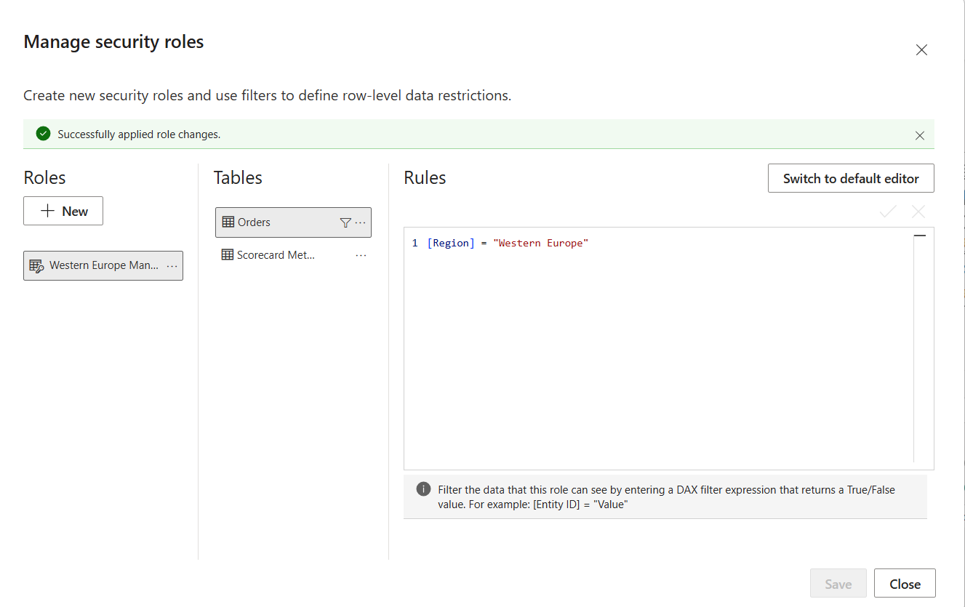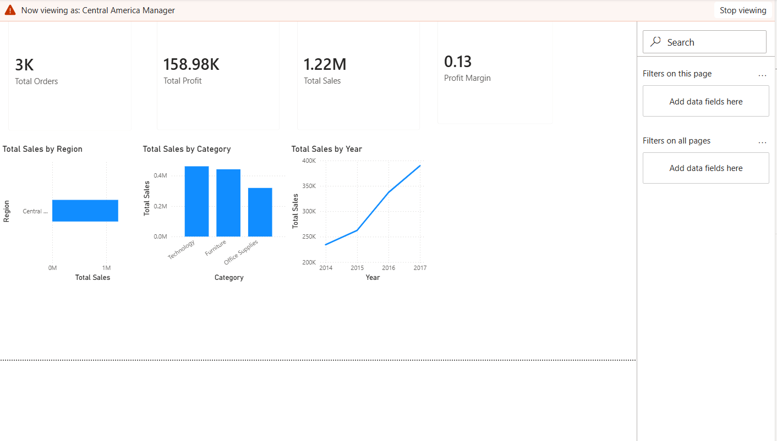
Step 2: Identify organizational users.
List the user categories required by the business scenario: CEO, Sales Manager, Finance Manager, and Regional Manager. These roles represent different information needs.
Step 3: Define information requirements for each role.
Specify the information each user needs. For example, the CEO may require an executive overview, the Sales Manager sales performance, the Finance Manager profit and financial metrics, and the Regional Manager regional results.
Step 4: Create a Role Matrix.
In Microsoft Excel, create a table with columns for User Role, Required Reports/Dashboards, Data Scope, and Access Requirement. Fill in the appropriate details for each role.

Fig 9.2: Role and information requirement matrix
Part B: Authentication Analysis
Step 5: Study authentication methods used in Power BI.
Review how users sign in to Power BI Service and note that organizational accounts are used to identify users within an organization.
Step 6: Compare authentication approaches.
Prepare a comparison table for username-password authentication, organizational accounts, and multi-factor authentication (MFA). Include the purpose, benefits, and security considerations of each method.
Step 7: Document the advantages of secure authentication.
Explain how secure sign-in helps prevent unauthorized access, protects organizational reports, and reduces the risk of account misuse.

Fig 9.3: Authentication methods comparison
Part C: Authorization and Access Control Design
Step 8: Create an Access Control Matrix.
In Excel, make a matrix with user roles as rows and reports or actions as columns. Include the permissions View, Edit, Share, and Admin.
Step 9: Define permission levels.
Use View for reading reports, Edit for modifying permitted content, Share for distributing access where authorized, and Admin for managing workspace settings and access.
Step 10: Assign permissions to user roles.
Assign only the permissions needed for each role. For example, executive and regional users may need view access, report authors may need edit access, and workspace administration should be restricted to designated administrators.
Step 11: Justify each permission assignment.
Add a short reason for each important assignment, based on job responsibilities and the principle of least privilege. Avoid giving users more access than they need.
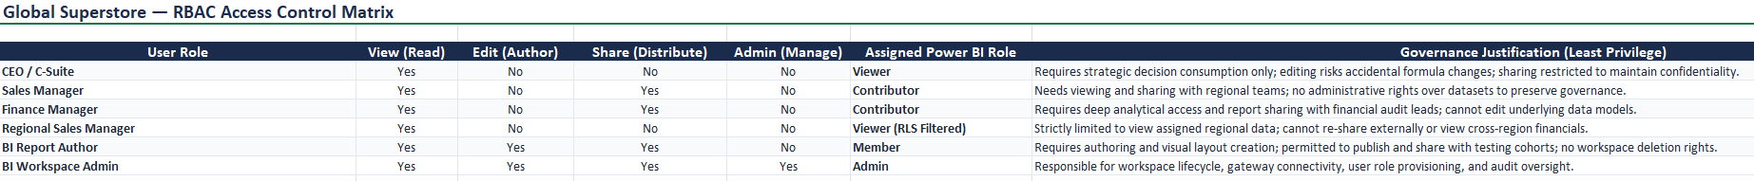

Fig 9.4: Access control matrix
Part D: Row-Level Security (RLS) Planning
Step 12: Design a Row-Level Security strategy.
Define regional access rules using the Region field in the Global Superstore dataset. For example, the North Region Manager should see only North Region data, and the South Region Manager should see only South Region data.
Step 13: Document the RLS design.
Prepare a table containing Role/User, Region Filter, Data Visible, and Purpose. Clearly identify which regional records each manager is permitted to view.
Step 14: Explain how RLS improves security.
Describe how RLS limits exposure of data, supports regional responsibilities, and helps prevent users from viewing records outside their authorized scope. If implementing in Power BI, create and test roles using the available modeling/security options.

Fig 9.5: Row-Level Security planning matrix
Part E: Security Risk Assessment
Step 15: Identify potential security risks.
List risks such as unauthorized access, excessive permissions, accidental data sharing or leakage, weak authentication, and incorrect regional data restrictions.
Step 16: Recommend security controls.
For each risk, suggest a mitigation measure. Examples include multi-factor authentication, least-privilege permissions, reviewing sharing settings, restricting administrative access, and testing RLS rules.
Step 17: Prepare a Security Recommendation Report.
Create a report with sections for the objective, user roles, authentication findings, access control design, RLS plan, identified risks, mitigation measures, and final recommendations.
Step 18: Review and validate the security plan.
Check that each role has appropriate report access, permissions are justified, regional restrictions are clear, and every identified risk has a corresponding control or mitigation action.
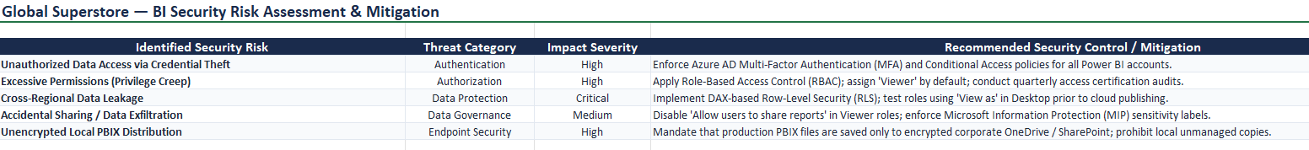
Fig 9.6: Security risk assessment and recommendations
7. RESULT:
A secure BI access strategy was designed using authentication, authorization, and access control principles. User roles, permissions, and Row-Level Security requirements were documented, and potential security risks with recommended mitigation measures were identified.
8. LEARNING OUTCOMES:
• Explained authentication, authorization, and access control concepts in BI systems. (CO1-BT2)
• Identified security requirements for different organizational roles. (CO1-BT2)
• Analyzed access control mechanisms and permission structures. (CO4-BT4)
• Evaluated security risks associated with BI deployments. (CO4-BT4)
• Designed secure access strategies for BI environments. (CO4-BT4)
9. DELIVERABLES:
• Role and Permission Matrix
• Access Control Matrix
• Row-Level Security Design Document
• Security Risk Assessment Report
• Security Recommendations Sheet

